Wireframing and Basic Layout

Christine Hodges

Rasmussen College

Author Note

This paper is being submitted on May 25th, 2018 for Darice Corey CIS4655 Advanced Mobile Web Application Development course.

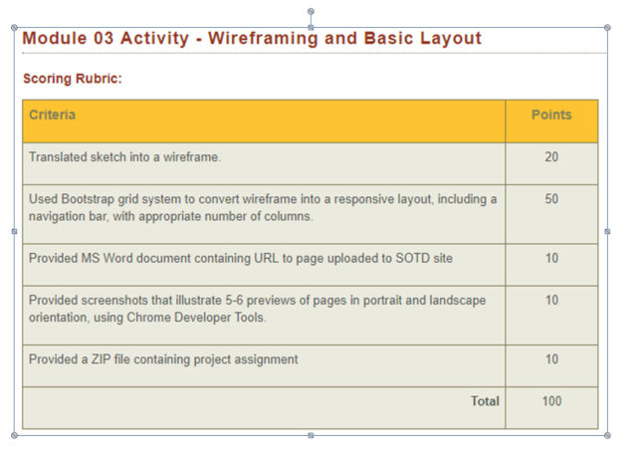

Translated sketch to wireframe

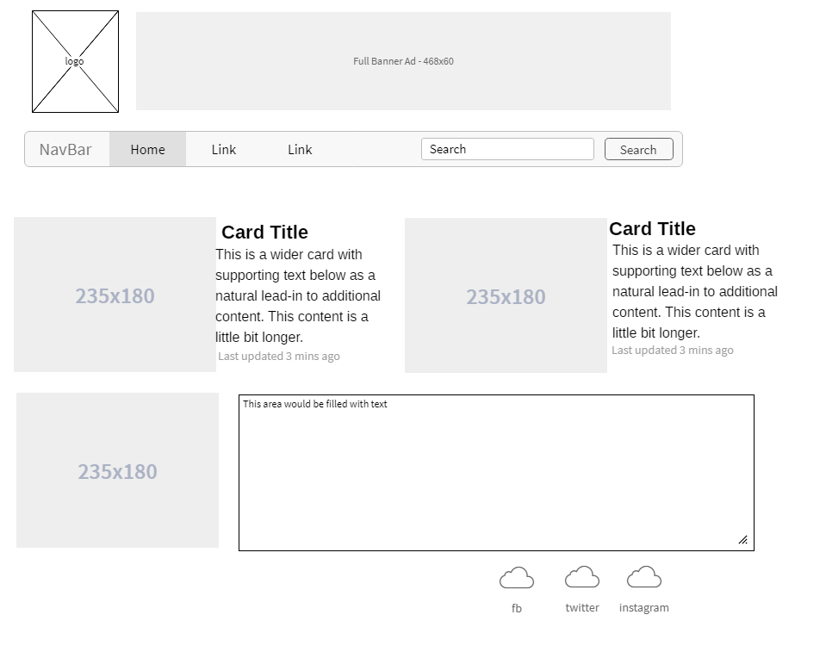

Convert bootstrap grid system to responsive layout, including nav bar, with appropriate number of columns

Providing URL to loaded SOTD site: <http://sotd.us/christinehodges/AdvWebDev/Module_03/activity/welcome.html>

<http://sotd.us/christinehodges/AdvWebDev/Module_03/activity/runners.html>

Provide screen shots 5-6 previews of pages in Chrome Dev

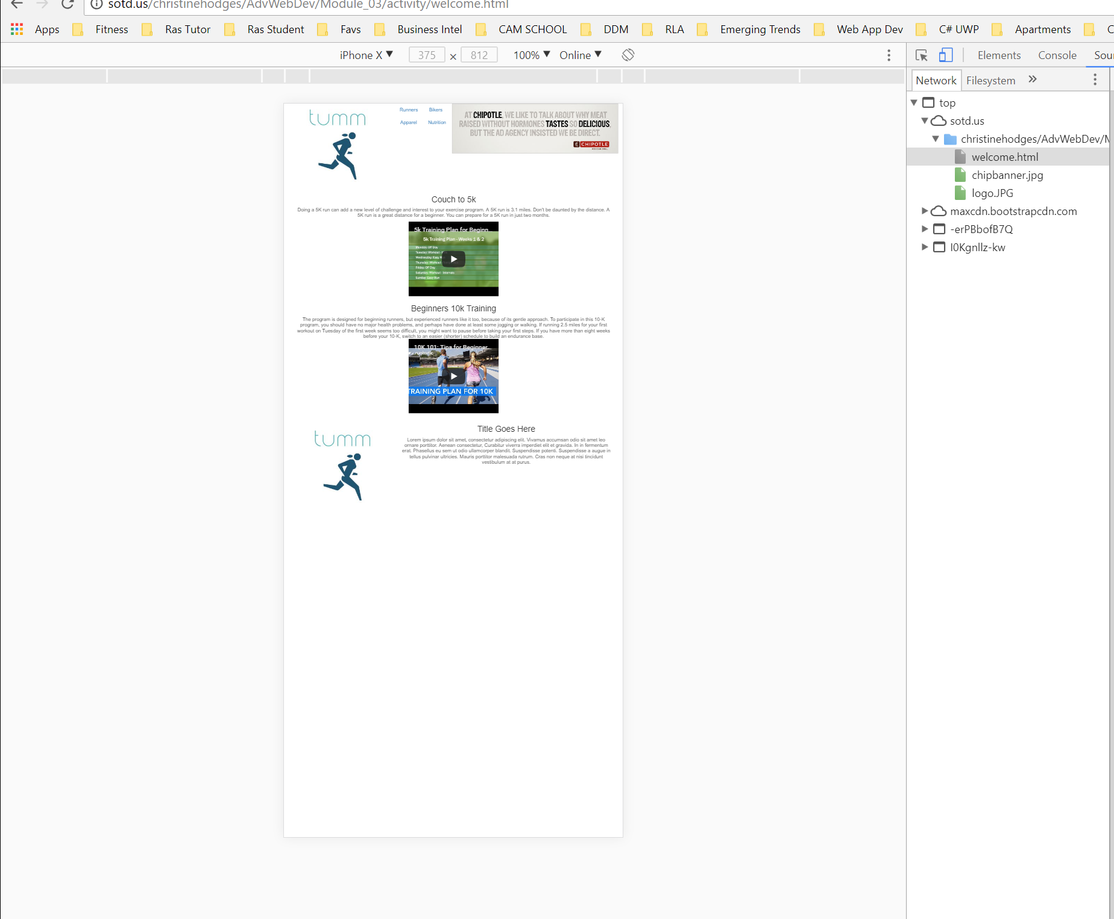

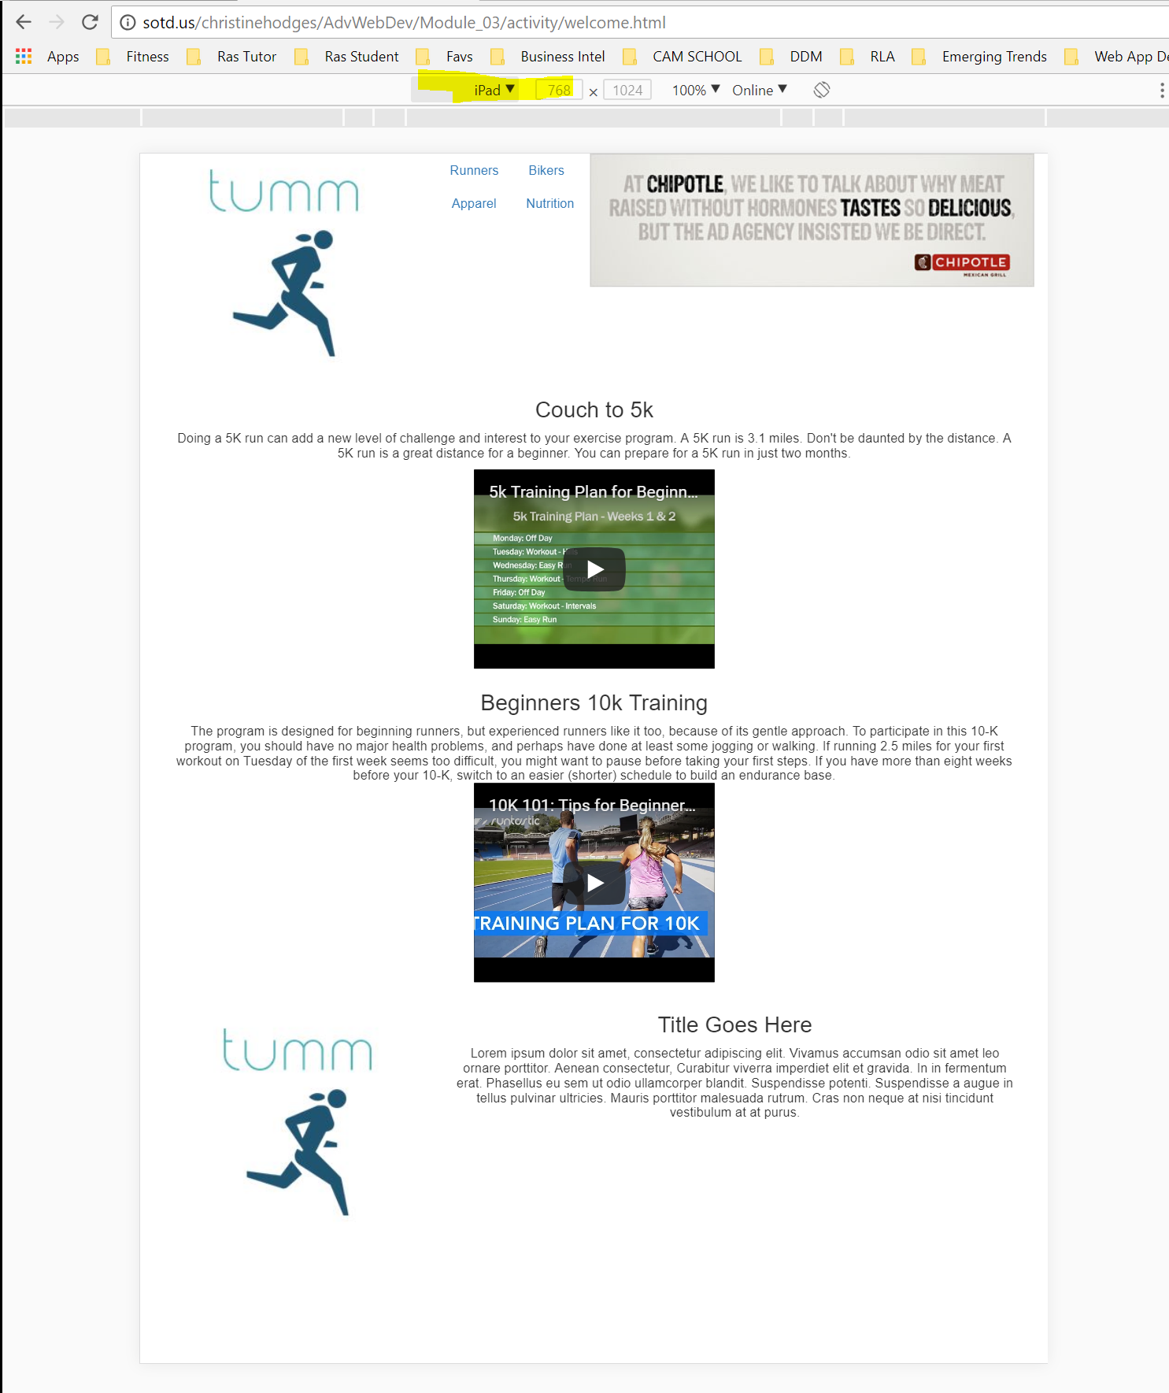

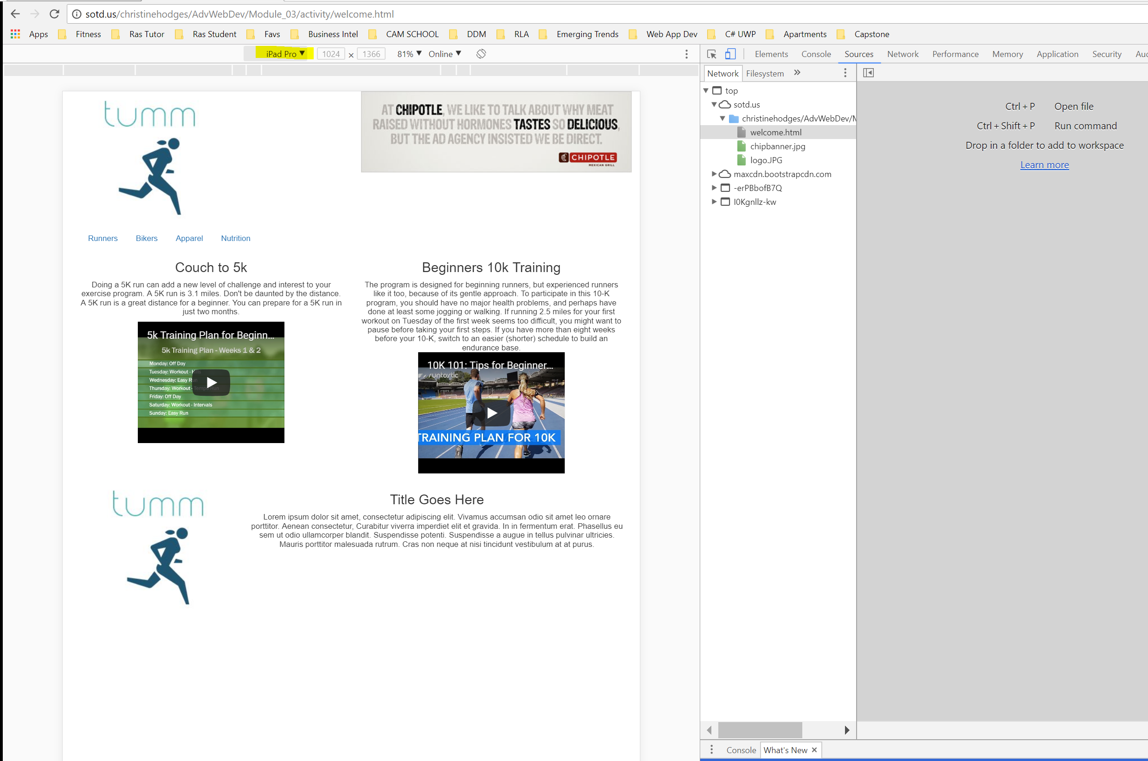

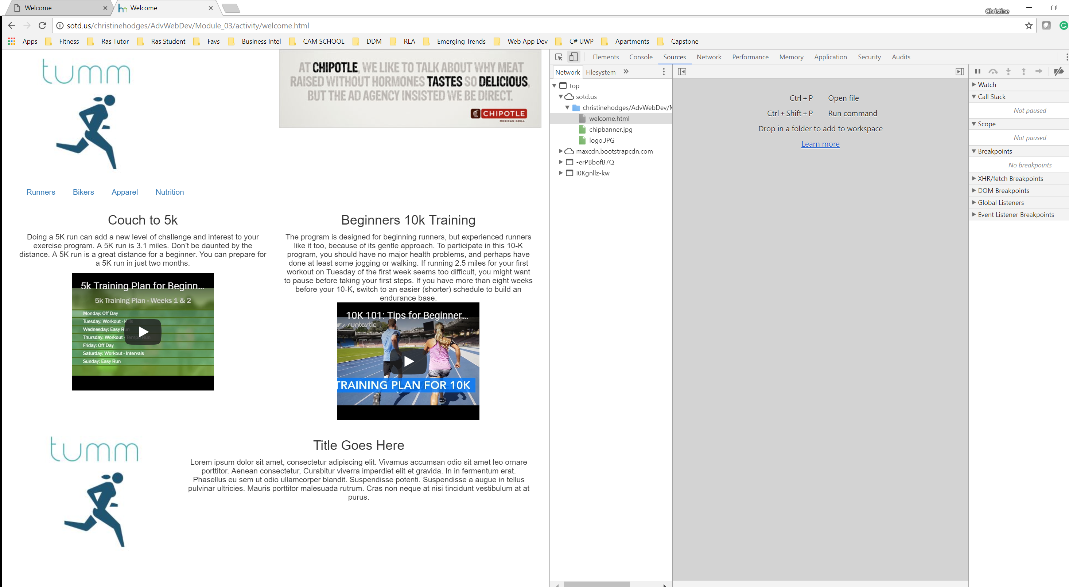

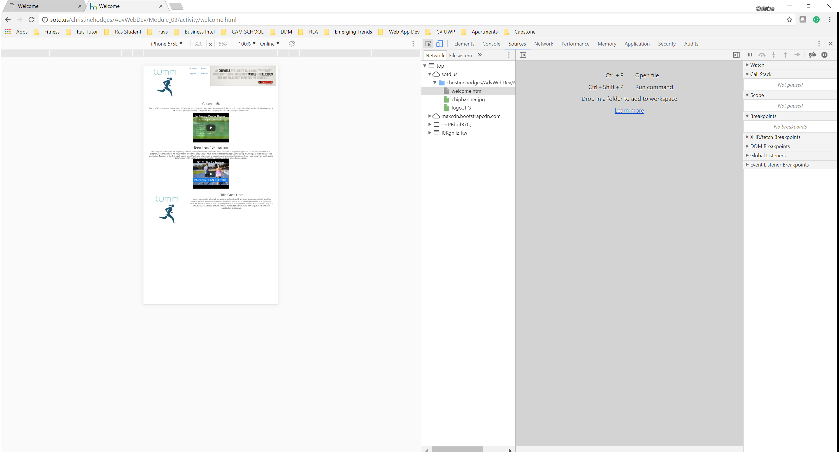

Zip File with project assignment